ASSIGNMENT 7 (c) — Section 1 AAA
(Authentication, Authorization, Accounting)
Shreya Panchal
Topic: Three Core Functions, AAA in Networking & Security, AAA Deployment Models

Theory Overview

1. The Three Core Functions of AAA
AAA is a comprehensive architectural framework for intelligently controlling access to computer network resources, enforcing enterprise security policies, and auditing usage.
Authentication (Who are you?): This is the first step where the system verifies the identity of the user attempting to access the network. It requires credentials such as a username and password, digital certificates, or biometric data.
Authorization (What are you allowed to do?): Once identity is proven, authorization determines what specific resources, services, privileges, or commands the authenticated user is permitted to use or execute based on their profile.
Accounting (What did you do and when?): This function tracks and measures the resources consumed by a user during their access session. It records details such as session start/stop times, data transferred, and commands executed, which is useful for billing, auditing, and capacity planning.

2. AAA Deployment Models
Centralized AAA Deployment: In this model, all network access control decisions are delegated to a centralized server or cluster of servers (such as a RADIUS or TACACS+ server). When a user connects to a router or switch, the network device queries the central server to process the request.
Distributed (Local) AAA Deployment: In this model, user authentication data and access policies are maintained directly on individual network devices (e.g., storing usernames/passwords locally in the router's configuration file).

Tasks & Answers

Task 1: Real-World Scenario — Airport Wi-Fi Access Control
Question: Write a short scenario where a user tries to access a private Wi-Fi network (like at a campus or airport) and describe how each of the three AAA functions — Authentication, Authorization, and Accounting — would apply step by step in this situation.
Answer:
Scenario Context: A traveler named Rahul arrives at an international airport terminal and attempts to connect his laptop to the high-speed airport passenger Wi-Fi network (Airport_Premium_WiFi).
Step 1 — Authentication (Identity Verification): Rahul selects the Wi-Fi network and a captive portal page pops up. He enters his mobile number and receives a One-Time Password (OTP) via SMS. When he enters the correct OTP, the network's AAA backend verifies his credentials, confirming that this is a valid identity.
Step 2 — Authorization (Privilege Assignment): After successful authentication, the AAA server checks Rahul's access tier profile. Because he is a standard passenger, the server passes instructions to the Wi-Fi access point to restrict his maximum download speed to 10 Mbps and allow access to the web, while blocking administrative or illegal network protocols.
Step 3 — Accounting (Activity Tracking): The moment Rahul begins browsing, the AAA system opens an active log session. It records exactly when he logged in (10:15 AM), monitors the total amount of data he downloads (e.g., 450 MB consumed), and marks the termination of the session when he disconnects at his boarding gate (11:45 AM). This log is saved for regulatory compliance and analytics.

Task 2: AAA Deployment Models Comparison
Question: Create a table comparing at least two different AAA deployment models (such as centralized vs. distributed), listing three advantages and three disadvantages of each for a company like Zomato that handles sensitive user data.
Answer:
Feature / Aspect | Centralized AAA Deployment | Distributed (Local) AAA Deployment
Concept | Authentication and policies are managed on a single, dedicated central server (e.g., Cisco ISE, FreeRADIUS). | User accounts and policies are manually configured on each individual server or router.
Advantage 1 | Simplified Management: Admin can add, update, or revoke access permissions for Zomato employees from one console. | No Single Point of Failure: If one server's local configuration breaks, others continue functioning normally.
Advantage 2 | Consistent Security Policies: Ensures strict compliance across all systems, ensuring data privacy regulations are applied everywhere equally. | Lower Initial Infrastructure Cost: No need to purchase dedicated, high-capacity centralized AAA server hardware or software licenses.
Advantage 3 | Detailed Global Auditing: Centralized logging makes it easier to track who accessed sensitive user data across the whole architecture. | Low Network Latency: Authentication checks happen instantly on the local device without sending traffic across a WAN link.
Disadvantage 1 | Single Point of Failure: If the centralized AAA server goes offline, authentication across all systems could fail simultaneously. | Administrative Nightmare: Managing access changes manually on thousands of distinct nodes or local endpoints is impossible at scale.
Disadvantage 2 | Network Dependency: Relies heavily on continuous internal network connectivity to reach the AAA server cluster. | Inconsistent Security: High risk of configuration drift, where one server forgets to revoke access for a terminated employee.
Disadvantage 3 | Increased Setup Complexity: Requires building secure communication protocols (RADIUS/TACACS+) between nodes and the core server. | Poor Audit Capabilities: Local logs are fragmented across separate machines, making comprehensive security audits difficult.

Task 3: AAA Integration Network Diagram
Question: Draw a simple network diagram (can be hand-drawn and photographed) showing how AAA servers are integrated into a typical enterprise network for user access control, labeling where Authentication, Authorization, and Accounting processes happen.
Answer:
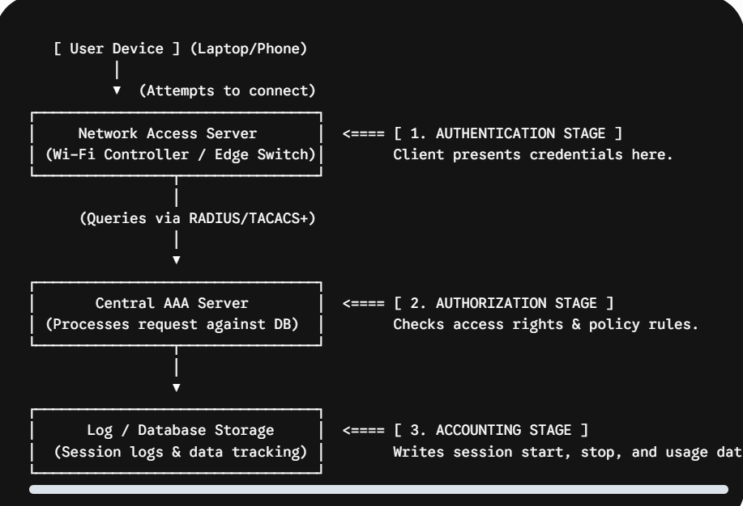

Task 4: Application-Level AAA — Paytm / Financial Apps
Question: Pick any app you use daily (Instagram, Paytm, or Flipkart) and write a paragraph explaining how AAA concepts could be applied to secure user logins and actions within that app. Hint: Think about what happens when you log in, what features you are allowed to use, and how your actions might be tracked for security or billing.
Answer:
When using a daily financial application like Paytm, AAA concepts form the backbone of security to protect sensitive financial records. Authentication takes place the moment you open the app, requiring a biometric fingerprint scan, a PIN, or an OTP sent to your registered mobile number to confirm your identity. Once logged in, Authorization kicks in silently behind the scenes; a standard user profile is authorized to view balances, scan UPI QR codes, or make payments, whereas structural features — like altering transaction thresholds or editing regulatory KYC documents — are locked away or require secondary authentication levels. Finally, Accounting tracks every action for compliance and security auditing. Every time you send money, pay a merchant, or add funds to a wallet, the app logs the exact timestamp, transaction ID, source bank, destination account, and amount transferred. This acts as both a receipt for the customer and an audit trail to prevent fraud.

Task 5: Sample Institutional Wi-Fi AAA Policy
Question: Use ChatGPT or any AI tool to generate a sample AAA policy for a college Wi-Fi network that restricts access to students only, allows certain websites, and logs all access attempts. Paste the generated policy and briefly explain how each AAA function is addressed.
Answer:
Generated Sample Policy Document:
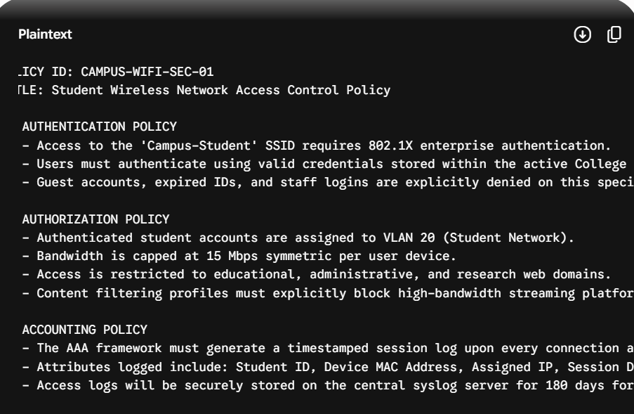
Brief Analysis of AAA Functions in this Policy:
How Authentication is Addressed: It enforces identity verification by connecting the Campus-Student network access to the active student directory, ensuring that only current students with active university accounts can pass the validation check.
How Authorization is Addressed: It sets the boundaries for what the authenticated student can do by moving them onto a specific student VLAN, setting bandwidth limits, and using content filters to block non-educational web platforms.
How Accounting is Addressed: It establishes a clear accountability trail by creating time-stamped logs of all session endpoints, bandwidth volumes, and device fingerprints, saving them for 180 days to fulfill regulatory auditing criteria.

